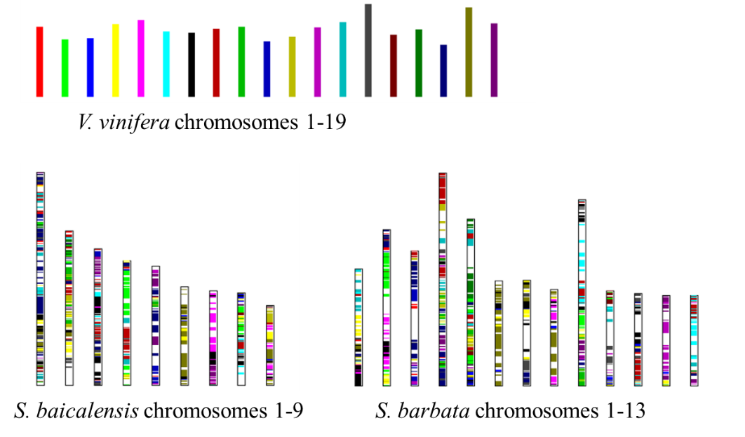

Supplementary Figure S9. The grape genome were painted into *S. baicalensis* and *S. barbata* genome, respectively, based on the gene collinearity using MCScanX.